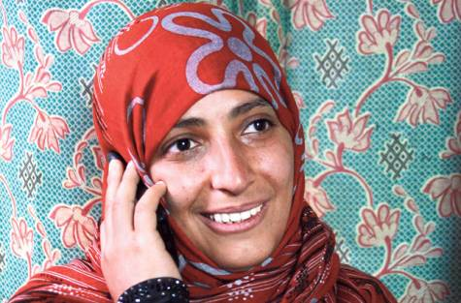

Her name is Tawakul Karman.
She is from Yemen.
She is a journalist.
She has 3 children.

She was the first Arab woman
to win the Nobel Peace Prize.

She wants women’s rights,
democracy
and peace in Yemen.

She was very happy when she won the prize.
She wants all the women
in Tunisia, Egypt, Yemen, Libya and Syria
to fight for their rights and freedom.

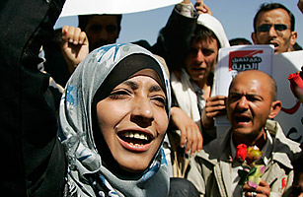

Her _ _ _ _ is Tawakul Karman.
She is _ _ _ _ Yemen.
She is a _ _ _ _ _ _ _ _ _ _.
She has 3 _ _ _ _ _ _ _ _.

She was the first Arab _ _ _ _ _
to win the Nobel Peace Prize.

She _ _ _ _ _ women’s rights,
democracy
and _ _ _ _ _ in Yemen.

She was very _ _ _ _ _ when she won the _ _ _ _ _.
She wants all the _ _ _ _ _
in Tunisia, Egypt, Yemen, Libya and Syria
to fight for their rights and _ _ _ _ _ _ _.

Please answer the questions

- What is her name?

- Where is she from?

- What is her occupation?

- How many children does she have?

- What does she want?
________________________________________________________________________________________________________________________________________________________

True or false

- Tawakul Karman is from France.
______________________________________

- She is a journalist.
______________________________________

- She has two children.
______________________________________

- She was the first Arab woman to win the Nobel Peace Prize.
______________________________________

- She was very sad when she won the prize.
______________________________________

