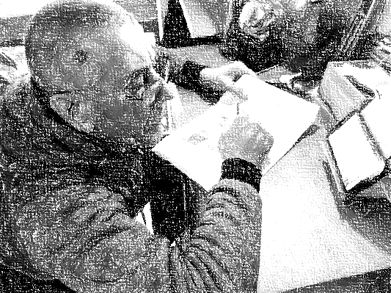

This is my friend.
His name is Victor.
He is from Moldova.
He is 60 years old.
He speaks Romanian, Russian and English.
He lives in Dublin 3.

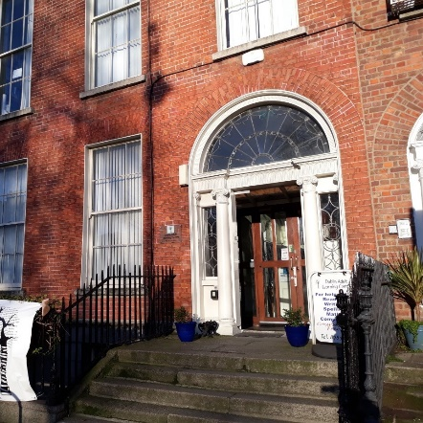

He goes to English reading and writing class at Dublin Adult Learning Centre.
He goes to class on Monday, Tuesday and Wednesday.
He likes to watch sport on TV.
Victor is a very happy man.

