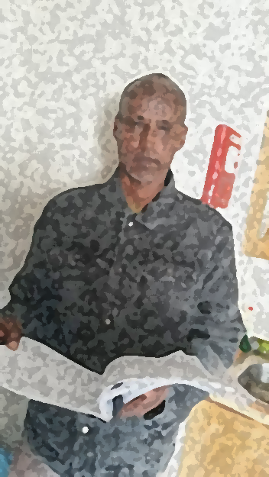

This is my friend.
His name is Ibrahim.
He is from Somalia.
He speaks Somali and English.
He lives in Dublin 7.
He came to Ireland in 2018.
His best friend’s name is Yaseen.

He goes to English reading and writing class at Dublin Adult Learning Centre.
His favourite food is rice, anjero and spaghetti.
Ibrahim likes to play football in Phoenix Park with his Somali brothers.

