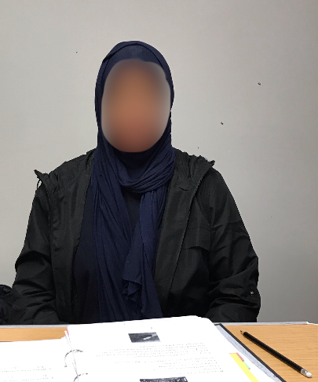

My name is Abshiro.
I am your friend.
I am from Somalia.
I speak Somali and a little English.
I live in Dublin 7.

I came to Ireland in 2017.
I have a cousin and an auntie in Dublin.

I like to read my English book and walk around my area.
I want to continue English class.
In the future, I want to go to college.

