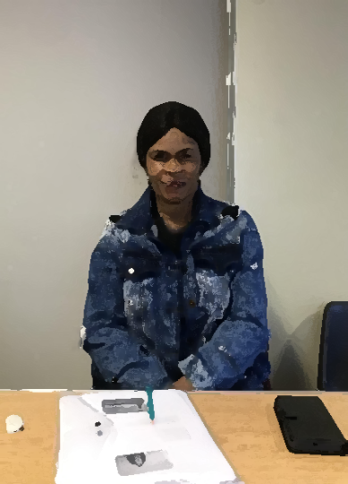
My name is Esther.
I am your friend.
I am from Congo.
I live in Dublin 7.
I live with my brother.
I came to Ireland in 2019.
On Sunday, I go to church.
In my free time, I like to practice English.
In the future, I want to be a dressmaker.
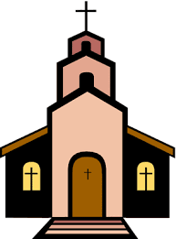

Now, you write.


- What is your name?
_______________________________________________

- Where are you from?
_______________________________________________

- Where do you live?
_______________________________________________

- Who do you live with?
______________________________________________________________________________________________

- When did you come to Ireland?
_______________________________________________

- What do you do on Sunday?
______________________________________________________________________________________________

- What do you do in your free time?
______________________________________________________________________________________________

- What do you want to do in the future?
______________________________________________________________________________________________

