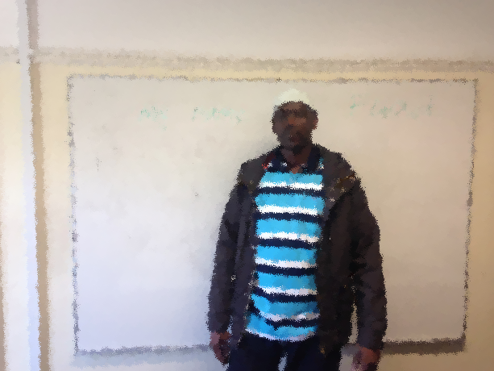

This is my friend.
His name is Adam.
He is from Somalia.
He is 32 years old.
He speaks Somali and English.
He lives in Dublin 7.

He goes to English class in Spirasi.
He goes to class on Tuesday, Wednesday, and Thursday.
He runs in the park every afternoon.
Adam is a very happy man.

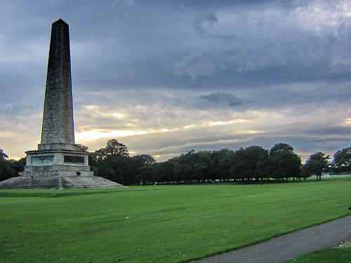

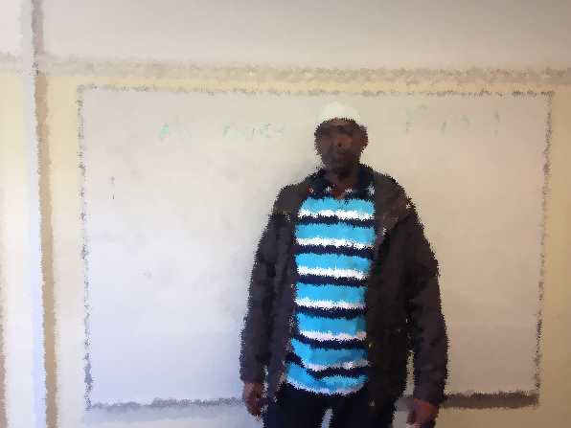

This is my _ _ iend.
His _ ame is _ dam.
He is from _ omalia.
He is 32 _ ears old.
He _ _eaks Soma_ i and English.
He _ ives in _ ublin 7.

He _ oes to English in Spirasi.
He goes to class on _ uesday, _ ednesday and _hursday.
He runs in the _ ark every _ fternoon.
Adam is a very _ appy _ an.

Please connect the sentences.

This is Somalia.

His name is Somali and English.

He is from Dublin 7.

He is 32 happy man.

He speaks in Spirasi.

He lives in Tues, Wed,Thurs

He goes to English class my friend.

He goes to class on every afternoon.

He runs in the park Adam.

Adam is a very years old.

Can you match these words?

name is lives from he

speaks Somali in English park

Friday class my Wednesday

Adam Thursday Spirasi

Wednesday Friday he

park my Somali in

Thursday is from English

name Spirasi class

lives speaks Adam

Please reorder these sentences.

- Adam/ His/ is/ name.
____________________________________

- Somalia/ He/ from/ is.
____________________________________

- 32 years/ old/ is/ He.
____________________________________

- speaks/ He/ and/ English/ Somali.
____________________________________

- lives/ He /Dublin 7/ in.
____________________________________

- every/ runs/ in the / He/ afternoon/ park.
____________________________________

7. man/ is/ Adam/ happy/ a/ very.
_____________________________________

