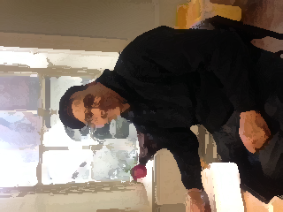

This is my friend.
His name is Ahmed.
He is from Morocco.
He is 57 years old.
He speaks Arabic and English.
He lives in Dublin 1.

He works in a Moroccan restaurant in the city centre.
He works on Wednesday,Thursday, Friday, Saturday and Sunday.
He works very hard.
Ahmed is a very kind man.



This is my _ _ iend.
His _ ame is Ahmed.
He is from _ orocco.
He is 57 _ ears old.
He _ _ eaks Ara_ ic and English.
He _ ives in _ ublin 1.

He _ orks in a Moroccan _ estaurant in the city centre.
He works on Wednesday, _ hursday, _ riday, _ aturday and Sunday.
He works _ ery _ ard.
Ahmed is a very _ ind _ an.



Please connect the sentences

This is restaurant in the city centre.

His name is Arabic and English.

He is from Thursday, Friday, Saturday
and Sunday.

He is 57 Ahmed.

He speaks my friend.

He lives in hard.

He works in a Moroccan Morocco.

He works on Wednesday, very kind man.

He works very years old.

Ahmed is a Dublin 1.

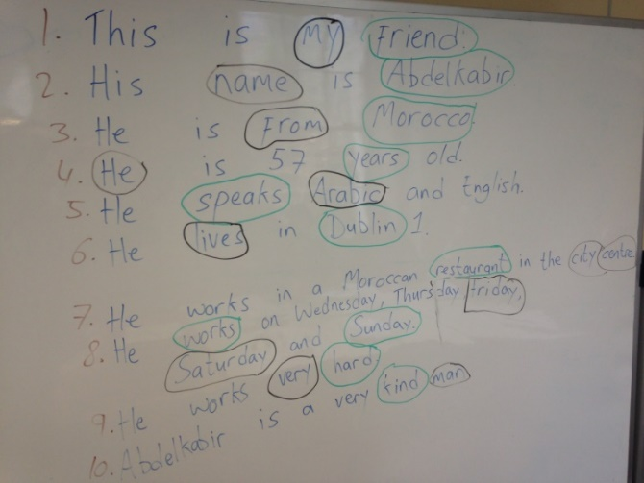

Can you match these words?

name is lives from he

speaks Arabic in English hard

Friday restaurant my Wednesday

Ahmed Thursday French
restaurant English

Wednesday Friday he

hard my Arabic

Thursday is in

name lives speaks

Ahmed French from

is

Please reorder these sentences:

- Ahmed/ His/ is/ name.
____________________________________

- Morocco/ He/ from/ is.
____________________________________

- 57 years/ old/ is/ He.
____________________________________

- speaks/ He/ and/ English/ Arabic.
____________________________________

- lives/ He /Ireland/ in.
____________________________________

- restaurant/ works/ in a / He.
____________________________________

7. works/ Wednesday/ He/ Thursday/ and/ on/
Sunday/ Friday/ Saturday.
____________________________________
____________________________________

