

My name is Adam. I am a taxi driver.
I am from Nigeria but I live in Ireland.
I am 43 years old. I am self-employed.
I don’t really like my job because sometimes I get abuse from bad people.
I would like to change my job in the future but I can’t at the moment because I must support my family.

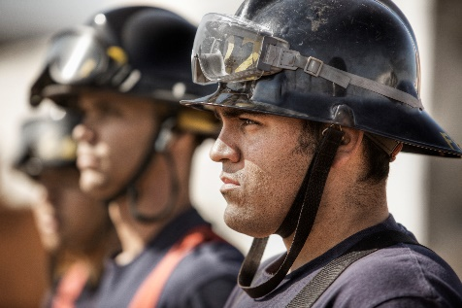

My name is Patrick. I am a fireman.
I am from Cork in Ireland.
I am 41 years old. I have 4 children.
I really like my job but sometimes it is very dangerous.
In my free time I love to run in marathons.

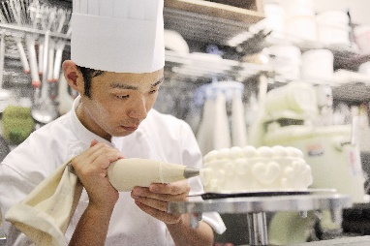

My name is Chang. I am a chef.
I was born in Hong Kong but I live in Ireland.
I have worked in some of the best restaurants in Ireland.
I have a lot of experience. I spent 5 years working in a 5-star hotel in Donegal. Now I am working at the 5-star Carton House in Kildare.
My hobby is eating good food in different restaurants.

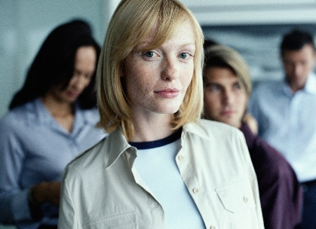

My name is Monika. I created a Polish women’s support group on Facebook to give help to Polish women.
I came to Ireland in 2005 and I work with Polish women who have depression and who feel lonely.
Many migrants come to Ireland and have mental health problems because they are away from their home.
I give support to these people.



- What’s his name?
_______________________________________________
- What does he do?
_______________________________________________
- Where is he from?
_______________________________________________
- How old is he?
_______________________________________________
- Why does he not like his job?
_______________________________________________

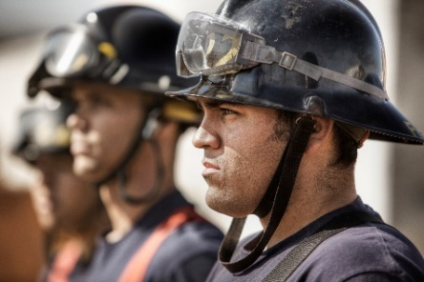

- What’s his name?
_____________________________________________
- What does he do?
_____________________________________________
- How old is he?
_____________________________________________
- How many children does he have?
_____________________________________________
- What does he do in his free time?
_____________________________________________

- What’s his name?
_______________________________________________
- What does he do?
_______________________________________________
- Where was he born?
_______________________________________________
- Where is he working at the moment?
_______________________________________________
- What is his hobby?
_______________________________________________

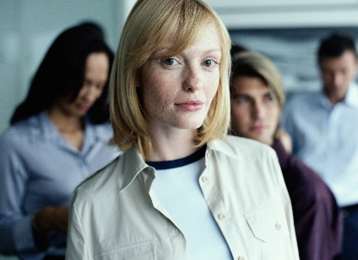

- What’s her name?
_______________________________________________
- What does she do?
_______________________________________________
- When did she come to Ireland?
_______________________________________________
- Who does she work with?
_______________________________________________

Put the words in the correct syllable box

▪ | ▪ ▪ | ▪ ▪ ▪ | ▪ ▪ ▪ ▪

Monika support Polish Facebook health

mental depression migrant group different

restaurant Kildare Donegal spent born

experience hotel dangerous fireman job

marathon children support family moment

abuse Nigeria taxi

First letter blends.
Put the blends in the correct place.

ta dr Ni Ir pe ch fu su

fa ch fr ch re ex cr Po

mi pr gr

_ _ oup _ _ oblems _ _ ee _ _ ture

_ _ ildren _ _ ople _ _ mily _ _ ef

_ _ perience _ _ staurant _ _ pport _ _ xi

_ _ ange _ _ grants _ _ lish _ _ eate

_ _ geria _ _ eland _ _ iver

Put the word from above into the sentence.

- There are many __________ people in Ireland.

- On my birthday I will eat in a _______________.

- Next year I will ___________ my job.

- I got married last year. Now I want to have a ___________.

- I never get a _________, they are very expensive.

- I have two _____________, one son and one daughter.

- Many ____________ come to Ireland looking for work.

- The capital city of ______________ is Abuja.

- I worked in kitchens for a long time. I was a _________.

- Dublin is the capital city of the Republic of __________.

