What did you do at Easter?

 | 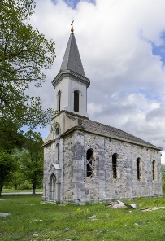 | 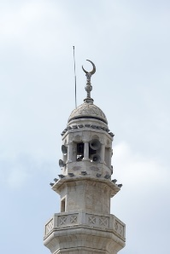 | 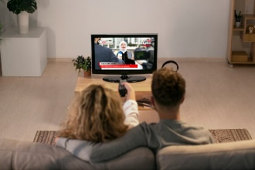
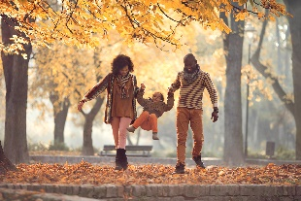 |  | 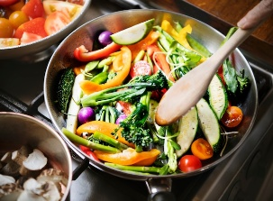 | 

travel phone my family eat chocolate

go to church watch television go to mosque

walk in the park cook healthy food

Connect these sentences.

- I ate a lot of chocolate at Easter!
_______________________________________________

- I enjoy watching television in the evening.
_______________________________________________

- I phone my family every two weeks.
_______________________________________________

- Every Saturday I take my family to the park.
_______________________________________________

- I go to church every Sunday.
_______________________________________________

- It’s important to cook healthy food.
_______________________________________________

- You will live longer.

- It helps me relax after a long day at work.

- Now I have put on a little weight.

- We go to the playground and play football.

- I talk to the priest and pray.

- I miss them a lot!!

What did you do at Easter? Write 7 sentences.

1. _________________________________________________

2._________________________________________________

3._________________________________________________

4._________________________________________________

5._________________________________________________

6._________________________________________________

7._________________________________________________

Easter holidays

I teach 5 days a week. It’s important to have a break from work.
I like Easter because it’s a time to relax and spend time with my family. This Easter I went on holidays for 1 week and worked for 1 week.

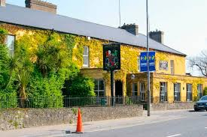
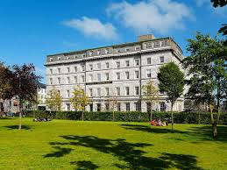
Adare, Limerick Galway City

I travelled to Galway by train and stayed in a hotel in the centre of Galway. I got a special online deal. The deal was for 3 nights and included 3 breakfasts and two dinners. I like Galway because it’s small and very friendly and you can walk everywhere.

After Galway, I travelled to Adare, outside Limerick. I met all my family in a hotel. We were celebrating my parent’s 50th wedding anniversary. I went swimming, played golf and ate a lot of food.

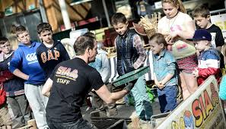
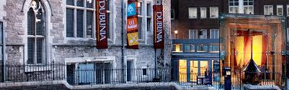
After my holidays I worked for 1 week at Dublinia beside Christchurch. I teach children archaeology. I teach children about their past.

Now I feel very rested and am ready for teaching adults!!

