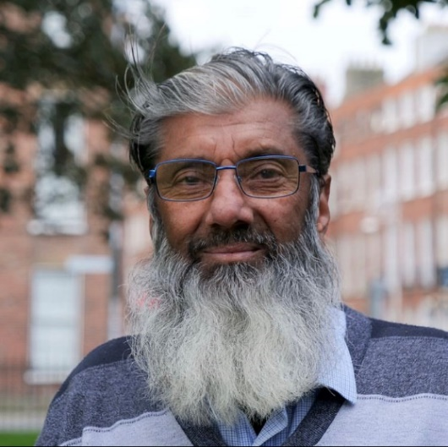

My name is Mohammad Younis.
I am your friend.
I was born in 1954.
I am from Jhelum in Pakistan.
I speak Urdu.
I have 9 children.
I have 19 grandchildren.
I live in an apartment in Dublin 8.
I came to Ireland in September 2002.
I went to school at Dublin Adult Learning Centre.

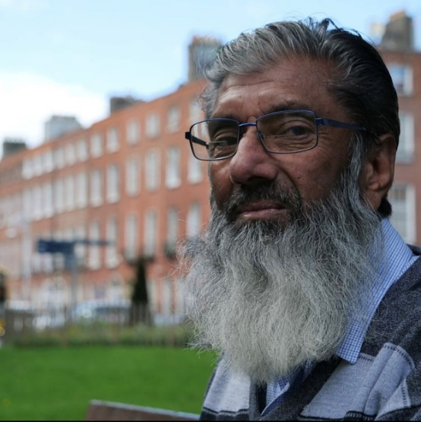
I came to Ireland to work as a chef.
I shared a room with 6 people.
I worked 11 hours every day, 7 days a week for two and a half years.
I started work at 4pm and finished at 3.30am.
I received €5,000 for all this work.
It was a very bad situation.

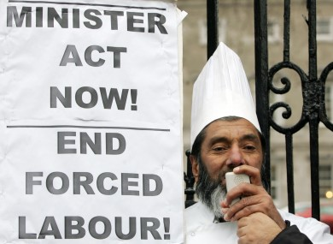

In 2009, The Migrant Rights Centre of Ireland helped me.
In 2011, I was awarded €91,000 by the Rights Commissioner.
But my old employer never paid me the money.
I never received the money.

I want to return to Pakistan because I miss my family and I have some health problems.

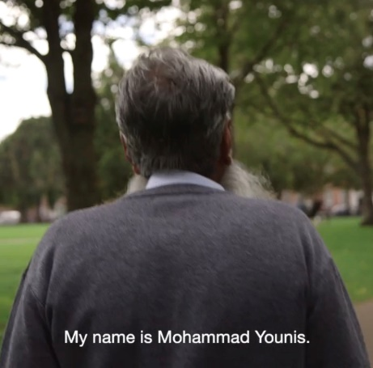
Please answer the following questions

- What is his name?
_______________________________________________

- When was he born?
_______________________________________________

- Where is he from?
_______________________________________________

- What language does he speak?
_______________________________________________

- How many children does he have?
_______________________________________________

- How many grandchildren does he have?
_______________________________________________

- Where does he live?
_______________________________________________

- When did he come to Ireland?
_______________________________________________

- Where did he go to school?
_______________________________________________

- Why did he come to Ireland?
_______________________________________________

- How many people did he share a room with?
_______________________________________________

- How many hours a day did he work?
_______________________________________________

- What time did he start and finish work at?
_______________________________________________

- How much money did he receive for all this work?
_______________________________________________

- In 2009, who helped him?
_______________________________________________

- In 2011, how much money was he awarded?
______________________________________________________________________________________________

- Did he receive the money?
_______________________________________________

- Why does he want to return to Pakistan?
______________________________________________________________________________________________

Workers’ rights in Ireland

- The national minimum wage for an adult employee is €11.30 per hour since 1 January 2023.

- Your maximum average working week cannot be more than 48 hours. You can work 48 hours in a week, but that your average weekly hours over 4 months should not be more than 48.

- You must receive a pay slip with every payment of wages.

- In general, you are entitled to a 15-minute break when you have worked more than 4½ hours.

- All full-time employees are entitled to 10 public holidays each year.

- Maternity leave: the mother is entitled to take 26 weeks maternity leave from work.

- Paternity leave: the father is entitled to 2 weeks paternity leave from work.

- You have the right to equal treatment in the workplace. Discrimination is against the law in Ireland.

Discrimination means treating a person unfairly because of who they are or because they possess certain characteristics.

You cannot be discriminated against because of gender, age,
race, civil status, family status, sexual orientation, disability,
religion, or Traveller community membership.

Match the words on page 7 to the definitions below

The lowest hourly pay that must be paid. Eg. the minimum wage in Ireland is €11.30 per hour.

It is a rule about what a person is allowed to do or have. Eg. In Ireland, it is my right to receive a 15-minute break when I have worked more than 4½ hours.

When someone is treated differently
because of race, gender, age, or sexual orientation. Eg. Olga was a victim of discrimination when she was not hired because her interviewer did not like women.

The biggest amount of something you can have.

Money that is paid by an employer to an employee on a daily or weekly basis, especially to a manual or unskilled worker. Eg. Hassan is paid a low wage at his job in the factory.

Having the legal right or permission to do something.

A day when almost everyone in a particular country does not have to go to work or school.

Time off from a job given to a mother to take care of a newborn child.

Time off from a job given to a father after a child is born
The principle that there will be no discrimination of workers based on racial or ethnic origin, sex, religion, or belief.

equal treatment maternity leave

right wages paternity leave

minimum wage maximum entitled

discrimination public holiday

Legal or illegal??

An employer says that women are not good workers and decides to pay them less than men to do the same job.

An employer says you cannot wear a hijab to work.

An employer will only pay his staff €11.30 per hour and no more.

An employer says a man can only have one week off work after his baby is born.

An employer says a woman must return to work 26 weeks after having her baby.

An employer says you must work 8 hours and only have one 15-minute break.

An employer says that everyone must be treated equally at work.

An employer says that you must work 80 hours per week.

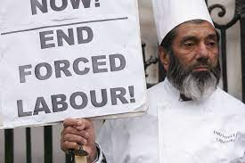

Workers’ rights in Ireland

- The minimum wage in Ireland is €11.30.

- You should not work more than 48 hours in a week.

- You must get a payslip from your employer.

- You should get a 15-minute break when you work 4½ hours.

- You should get 10 public holidays each year.

- You should get 26 weeks maternity leave from work.

- You should get 2 weeks paternity leave from work.

- Everyone must be treated equally at work.
No discrimination.

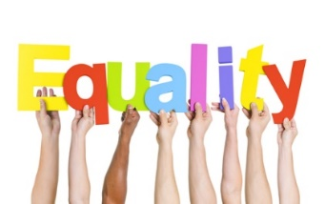
Write the words under the pictures

 | 
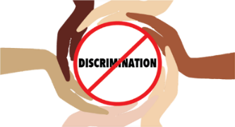 | 
 | 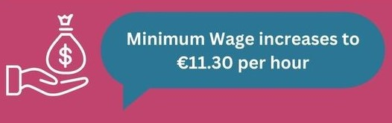
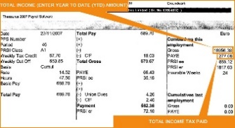 | 

payslip public holiday paternity leave

minimum wage no discrimination break

maternity leave 48 hours work

Please match the following

1 | The minimum wage is |  | more than 48 hours
2 | You should not work |  | each year
3 | You must get a payslip |  | from your employer
4 | 15-minute break |  | maternity leave
5 | 10 public holidays |  | paternity leave
6 | 26 weeks |  | discrimination at work
7 | 2 weeks |  | €11.30
8 | No |  | every 4½ hours

