

This is David. He is from France.
He is 34 years old.
He is medium-height.
He has straight brown hair.
He has brown eyes.
He has a beard.
He likes running and watching sport on TV.

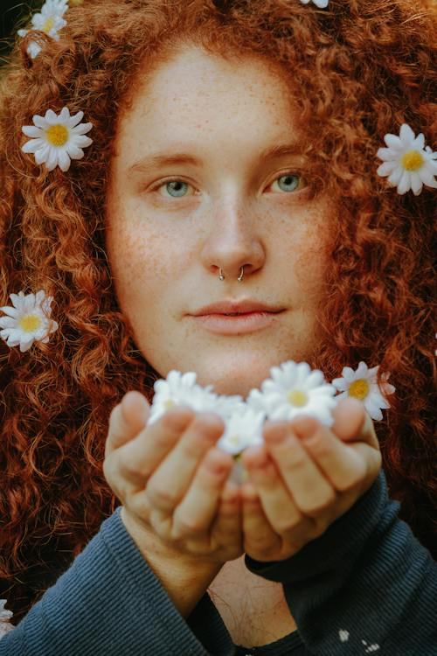

This is Fiona. She is from Ireland.
She is 29 years old.
She is short.
She has freckles.
She has long red hair.
She has blue eyes.
She likes reading and painting.

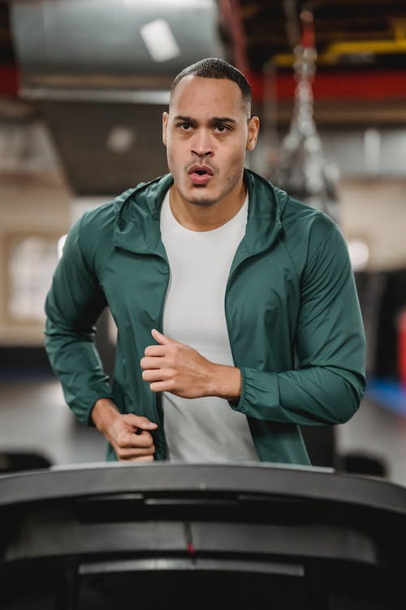

This is Sam. He is from America.
He is 38 years old.
He is tall.
He has broad shoulders.
He has short brown hair.
He has brown eyes.
He likes going to the gym.

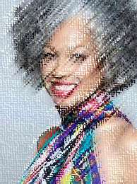

This is Michelle. She is from South Africa.
She is 47 years old.
She is medium-height.
She has curly grey hair.
She has brown eyes.
She likes travelling.

Put the sentences in the correct order.



- 34 / He / years / old / is.
_______________________________________________
- straight / has / brown / hair/ He.
_______________________________________________
- a / He / beard / has.
_______________________________________________
- TV / He likes / and / watching sport / on / running.
_______________________________________________

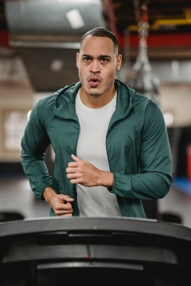

- years / is / old / He / 38.
_____________________________________________
- broad / He / shoulders / has.
_____________________________________________
- short / He / brown / hair / has.
_____________________________________________
- going / gym / to / likes / He / the.
_____________________________________________

Answer the questions.

- What’s her name?
___________________________________________
- Where is she from?
___________________________________________
- Is she short?
___________________________________________
- Does she have freckles?
___________________________________________
- What colour hair does she have?
___________________________________________
- What colour eyes does she have?
___________________________________________
- What does she like?
___________________________________________

- What’s her name?
_______________________________________________
- Where’s she from?
_______________________________________________
- Is she tall?
_______________________________________________
- What colour hair does she have?
_______________________________________________
- What colour eyes does she have?
_______________________________________________
- What does she like?
_______________________________________________

This is _ avi _ . He is from _ _ ance.
He is 34 _ ears _ ld.
He is _ _ dium-height.
He has _ _ _aight _ _ own _ air.
He has brown _ _es.
He has a _ ear_ .
He likes _ _nning and wat_ _ing _ _ ort on TV.

This is Fiona. _ _ e is from _ _ _ _ _ _ _.
She is 29 years old.
She is _ _ ort.
She has _ _ eckles.
She has _ong _ _ _ h_ _ _.
She has _ _ ue eyes.
She likes r_ _ding and p_ _nting.

This is Sam. He is from _ mer_ c_ .
He is 38 years old.
He is t_ _ _.
He has _ _oad _ _oulders.
He has short br_ _n hair.
He has brown eyes.
He likes go_ _ _ to the _ _ _.

This is Michelle. She is from _ ou_ _ _ _ ric_.
She is 47 years old.
She is medium-height.
She has cur_ _ _ _ey hair.
She has brown eyes.
She likes _ _avelling.

Write the words below into the correct box.

France Ireland America South Africa Michelle tall short

Sam David Fiona 47 38 34 29 reading /painting

medium-height freckles beard broad shoulders brown eyes

blue eyes short brown hair curly grey hair straight brown hair

long red hair travelling going to the gym running and watching TV

  Name: | 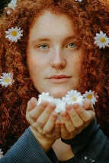  Name:
  Name: | 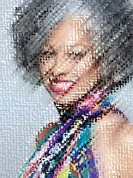  Name:

Ask people in the class the following questions.

- What’s your name?
_______________________________________________
- Where are you from?
_______________________________________________
- How old are you?
_______________________________________________
- What height are you?
_______________________________________________
- What colour hair do you have?
_______________________________________________
- What colour eyes do you have?
_______________________________________________
- What do you like to do?
_______________________________________________

Ask your friend the following questions.

- What’s your name?
_______________________________________________
- Where are you from?
_______________________________________________
- How old are you?
_______________________________________________
- What height are you?
_______________________________________________
- What colour hair do you have?
_______________________________________________
- What colour eyes do you have?
_______________________________________________
- What do you like to do?
_______________________________________________

Ask your friend the following questions.

- What’s your name?
_______________________________________________
- Where are you from?
_______________________________________________
- How old are you?
_______________________________________________
- What height are you?
_______________________________________________
- What colour hair do you have?
_______________________________________________
- What colour eyes do you have?
_______________________________________________
- What do you like to do?
_______________________________________________

Ask your friend the following questions.

- What’s your name?
_______________________________________________
- Where are you from?
_______________________________________________
- How old are you?
_______________________________________________
- What height are you?
_______________________________________________
- What colour hair do you have?
_______________________________________________
- What colour eyes do you have?
_______________________________________________
- What do you like to do?
_______________________________________________
Ask your friend the following questions.

- What’s your name?
_______________________________________________
- Where are you from?
_______________________________________________
- How old are you?
_______________________________________________
- What height are you?
_______________________________________________
- What colour hair do you have?
_______________________________________________
- What colour eyes do you have?
_______________________________________________
- What do you like to do?
_______________________________________________

Ask your friend the following questions.

- What’s your name?
_______________________________________________
- Where are you from?
_______________________________________________
- How old are you?
_______________________________________________
- What height are you?
_______________________________________________
- What colour hair do you have?
_______________________________________________
- What colour eyes do you have?
_______________________________________________
- What do you like to do?
_______________________________________________

Ask your friend the following questions.

- What’s your name?
_______________________________________________
- Where are you from?
_______________________________________________
- How old are you?
_______________________________________________
- What height are you?
_______________________________________________
- What colour hair do you have?
_______________________________________________
- What colour eyes do you have?
_______________________________________________
- What do you like to do?
_______________________________________________

Ask your friend the following questions.

- What’s your name?
_______________________________________________
- Where are you from?
_______________________________________________
- How old are you?
_______________________________________________
- What height are you?
_______________________________________________
- What colour hair do you have?
_______________________________________________
- What colour eyes do you have?
_______________________________________________
- What do you like to do?
_______________________________________________

