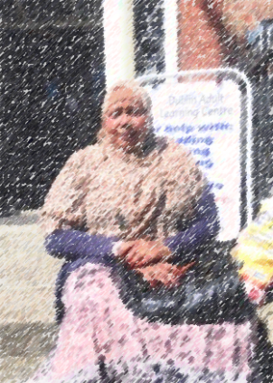

This is my friend. Her name is Faduma.
She is from Somalia.
She has been in Ireland for 17 years.
She lives on North Circular Road in Dublin 7.
She likes where she lives because many of her friends live in the same building. Her best friends’ names are Halima and Zeinab.

For many years Faduma studied in two different schools.
On Tuesday, Wednesday and Thursday morning she studied English in Phibsboro. The name of this school is Spirasi. She doesn’t go to Spirasi anymore because she is too busy.

On Monday, Tuesday and Wednesday afternoon Faduma studies at Dublin Adult Learning Centre on Mountjoy Square in Dublin 1. She studies English reading and writing. Her teacher’s name is Cathy.

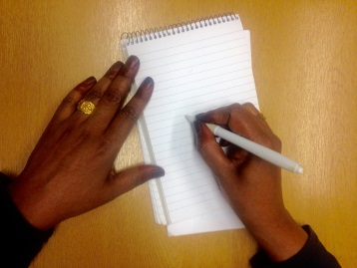
Faduma walks to school. She likes walking to school because it is good exercise. It takes her 45 minutes to walk to school.

Every Sunday she also goes to a gym near Cork Street in Dublin 8. She goes to the gym from 7-9pm. This time is for women only. She likes to use the gym equipment and the sauna.
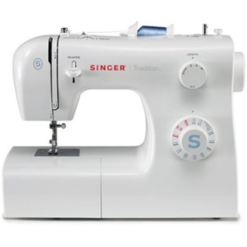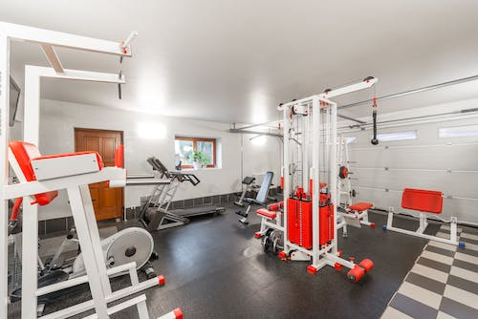

Every Monday Faduma goes to a women’s group in Crosscare in Dublin 3. The group starts at 11 am and finishes at 1 pm.
Women from all over the world come to this group.

In her free time Faduma makes traditional Somali dresses. She makes the dresses using a sewing machine. She started learning how to use a sewing machine when she lived in Galway. 8 years ago, she did a sewing course for 2 months in Ozanam House in Dublin 1. She learned a lot of things about sewing in the course.

Faduma likes to make dresses for other women.
In the future she would like to start a business selling traditional dresses.

Please answer the following questions

1. What is her name?
____________________________________________

2. Where is she from?
____________________________________________

3. How long has she been in Ireland?
____________________________________________

4. Where does she live in Ireland?
____________________________________________

5. Why does she like where she lives?
________________________________________________________________________________________

6. What are her friends’ names?
____________________________________________

7. What days did she study English in Phibsboro?
________________________________________________________________________________________

8. What is the name of this school?
____________________________________________

9. Why doesn’t she go to Spirasi anymore?
____________________________________________________________________________________________________________________________________

10. What days does she study at Dublin Adult Learning Centre?
________________________________________________________________________________________

11. What is her teacher’s name?
____________________________________________

12. Why does she like walking to school?
________________________________________________________________________________________

13. How long does it take her to walk to school?
____________________________________________

14. What does she do every Sunday?
____________________________________________

15. What time does she go to the gym from?
____________________________________________

16. Can men use the gym at this time?
____________________________________________

17. What does Faduma do every Monday?
________________________________________________________________________________________

18. What time does this group start and finish?
____________________________________________

19. Who comes to this group?
____________________________________________

20. What does Faduma do in her free time?
____________________________________________

21. Where did she start learning to use a sewing machine?
________________________________________________________________________________________

22. Where did she do a sewing course for 2 months?
________________________________________________________________________________________

23. Who does Faduma like to make dresses for?
____________________________________________

24. What would she like to do in the future?
________________________________________________________________________________________
▪ | ▪▪ | ▪▪▪ | ▪▪▪▪

friend Somalia Ireland circular Dublin machine only
same building Zeinab many years afternoon sauna

Galway morning school apartment business gym equipment

adult Mountjoy writing exercise walk Crosscare
finishes world group traditional Somali
Put the words below into the correct rhyme box

friend | same | many | years | school | walk | gym | group

bend loop him talk penny blame jewel scoop

spend shame rule tears Jenny chalk slim beers

came soup cheers swim lend any hawk pool

Break the words into syllables.
The first one is done for you.
1. | Ireland | Ire | land
2. | Somalia
3. | circular
4. | Dublin
5. | building
6. | many
7. | morning
8. | apartment
9. | afternoon
10. | adult
11. | Mountjoy
12. | writing
13. | exercise
14. | only
15. | equipment
16. | sauna
17. | Crosscare
18. | traditional
19. | Somali
20. | machine
21. | Galway

Please correct the spelling

1. ifrdne _ _ _ _ _ _

2. mean _ _ _ _

3. eIdlnar _ _ _ _ _ _ _

4. cebesua _ _ _ _ _ _ _

5. ulniDb _ _ _ _ _ _

6. niguibdl _ _ _ _ _ _ _ _

7. oochsl _ _ _ _ _ _

8. ginrmon _ _ _ _ _ _ _

9. ngEishl _ _ _ _ _ _ _

10. temntrapa _ _ _ _ _ _ _ _

11. nnooertfa _ _ _ _ _ _ _ _ _

12. igneard _ _ _ _ _ _ _

13. ginwirt _ _ _ _ _ _ _

14. lkaw _ _ _ _

15. cisexre _ _ _ _ _ _ _ _

16. myg _ _ _

17. enwom _ _ _ _ _

18. oupgr _ _ _ _ _

19. ldorw _ _ _ _ _

20. trdaialtion _ _ _ _ _ _ _ _ _ _ _

21. ssedr _ _ _ _ _

21. inechma _ _ _ _ _ _ _

22. wayGal _ _ _ _ _ _

23. thmon _ _ _ _ _

24. ssacl _ _ _ _ _

25. turefu _ _ _ _ _ _

26. nessibus _ _ _ _

