A visit to a Farmer’s Market

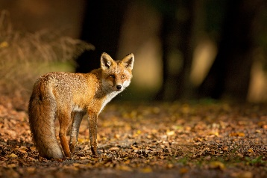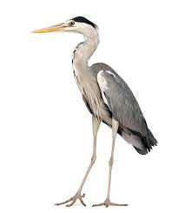
My name is Susan. I am a schoolteacher.
I am 30 years old. I am from Galway, but I live in Dublin. I live near a river. I like my house because I can hear the sound of the stream every day. I hear the birds singing in the trees.
Sometimes I see a fox and sometimes I see a heron.

I work 5 days per week. I have free time at the weekend. Every Saturday I visit the Farmer’s Market.
There is always a crowd of people. They chat and talk.
They are very loud. Children play hopscotch and run around.
Everybody is happy. The food is fresh and healthy.

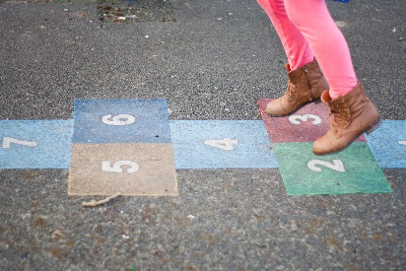


I buy many fruits and vegetables. I like peaches, apples and bananas but I don’t like pineapple. I really like spinach but I hate broccoli.
I pay for my food and I sit down with my friends.
I eat a beef sandwich and drink a cup of green tea.
I usually have ice-cream when it is a sunny day.
I leave the farmer’s market at 4pm. I am a little sad.
But I say to myself, “Tomorrow is another day ! “

Look at the words. Match the words with the pictures.
The first one is complete.


ice- cream hopscotch peaches bird singing sunny fox

woman vegetables heron trees stream children playing

 |  | 
ice-cream
 | 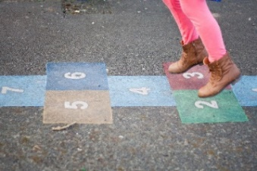 | 
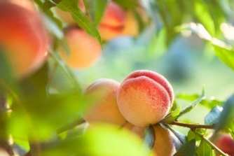 | 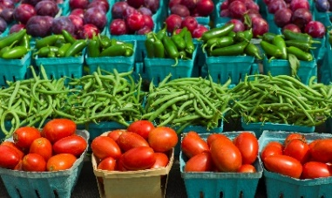 | 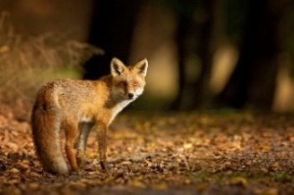
 | 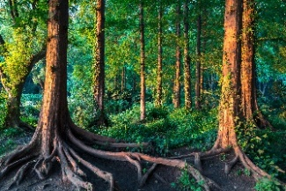 | 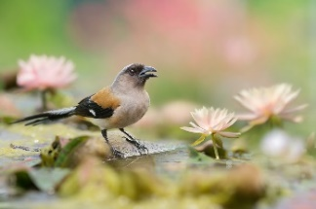
Look at the words.
Listen to your teacher say the word.
Tick the word you hear.

name teacher years near house hear

stream trees week free crowd chat loud

children play hopscotch around happy

many really pay down leave say eat

beef green tea sunny cream brown

fee feet town feel game blouse tray

chair dream brow fear cheer blame

creature spouse meat coffee pray cheek

clown dame church beans chocolate

sound peaches rear

Look at the words on Page 3.
Many words have the same pattern and same sound.
Put the words with the same pattern or sound in the correct place.
Some words go in two places.
/ea/  (not ear words!) | /ear/  (including -eer) | _ a _ e  (long a vowel sound)
1. | 1. | 1.
2. | 2. | 2.
3. | 3. | 3.
4. | 4. | 4.
5. | 5. | 5.
6. | 6.
7. | /y/  (long e vowel sound) | /ay/  (long a vowel sound)
8. | 1. | 1.
9. | 2. | 2.
10. | 3. | 3.
11. | 4. | 4.
12. |  | 5.
 |  | 6.
/ee/  (long e vowel sound) | /ch/ | /ou/
1. | 1. | 1.
2. | 2. | 2.
3. | 3. | 3.
4. | 4. | 4.
5. | 5. | 5.
6. | 6. | 6.
7. | 7. | /ow/
8. | 8. | 1.
9. | 9. | 2.
10. | 10. | 3.
 |  | 4.
 |  | 5.
 |  | 6.

Look at the words in the box.
Put the words in the correct place.
The first one is complete.
trees hear years week free teacher

crowd loud play around happy green tea

peaches pay down eat beef leave

1. I am a school teacher.

- I am 30 _ _ _ _ _ old.

- I _ _ _ _ the birds singing in the _ _ _ _ _.

- I work 5 days per _ _ _ _.

- I have _ _ _ _ time at the weekend.

- There is always a _ _ _ _ _ of people.

- They are very _ _ _ _.

- Children _ _ _ _ hopscotch and run _ _ _ _ _ _.

- Everybody is _ _ _ _ _.

10. I like _ _ _ _ _ _ _ , apples and bananas.

11. I _ _ _ for my food and sit _ _ _ _ with my friends.

12. I _ _ _ a _ _ _ _ sandwich and drink a cup of _ _ _ _ _ _ _ _.

13. I _ _ _ _ _ the farmer’s market at 4pm.
Jumbled letters. Write the word in the correct order.
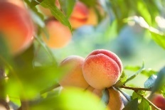 | c e p h a | _ _ _ _ _
 | n u s y n | _ _ _ _ _
 | e m t a s r | _ _ _ _ _ _
 | e t s r e | _ _ _ _ _
 | r a h e | _ _ _ _
 | w c d r o | _ _ _ _ _
 | n c d r l e i h | _ _ _ _ _ _ _ _
 | p h y a p | _ _ _ _ _
 | t a e | _ _ _
 | s e b a n | _ _ _ _
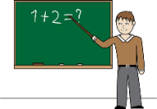 | r t a c e h e | _ _ _ _ _ _ _

 | e n g e r | _ _ _ _ _
 | e t a | _ _ _
 | w b o r n | _ _ _ _ _
 | e t e f | _ _ _ _
 | o l e u s b | _ _ _ _ _ _
 | y a p r | _ _ _ _
 | h r c i a | _ _ _ _ _
 | p h y a p | _ _ _ _ _
 | e o e f c f | _ _ _ _ _ _
 | w d n o | _ _ _ _ _
 | c u h r h c | _ _ _ _ _ _

Please circle the correct spelling.

teachar | teacher
years | yeers
stream | streem
hause | house
sownd | sound
treas | trees
every | evary
croud | crowd
lowd | loud
children | shildren
plai | play
fresh | frech
friut | fruit
friends | freinds
sunni | sunny
green | grean

I eat | you eat | he/she eats
I live | you live | he/she lives
I have | you have | he/she has

- What is Susan’s occupation?
_________________________________________________________

- Where is she from?
_________________________________________________________

- Where does she live?
_________________________________________________________

- Why does she like her house?
__________________________________________________________________________________________________________________

- How many days per week does she work?
_________________________________________________________

- Where does she visit every Saturday?
_________________________________________________________

- What does she buy at the Farmer’s Market?
_________________________________________________________

- What fruit and vegetables does she like?
_________________________________________________________

- What does she not like?
_________________________________________________________

- What does she eat at the farmer’s market?
_________________________________________________________

- What does she have when it is a sunny day?
_________________________________________________________

- What time does she leave the farmer’s market at?
_________________________________________________________

Look at the words.
Which words are fruit and which words are vegetables?

garlic banana spinach orange apple

cherries potato celery cucumber pineapple

green beans peach broccoli tomato

onion melon carrot mango kale pears

strawberries cabbage mango lettuce grapes

fruit | vegetables

