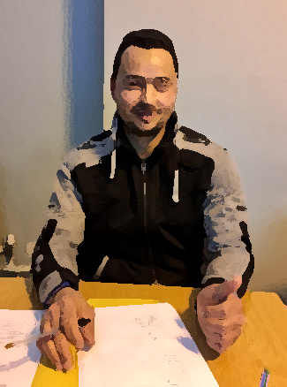

This is my friend. His name is Yussef.
He is 32 years old.
He is young. He is medium height.
He has brown eyes. He has black hair.
He is handsome.

He is from Egypt.
He is a painter.
He lives in Dublin 2 in Portobello.
He has been in Ireland for 3 years.
He likes playing football.

His favourite day of the week is Friday because he goes to the mosque.
He came to Ireland to look for a good job.

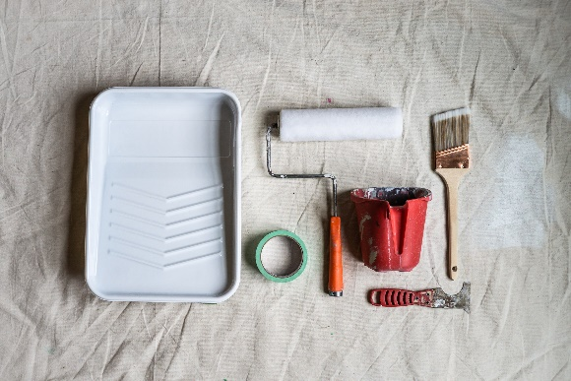
Please answer the following questions

1. What’s his name?
___________________________________________________
2. How old is he?
___________________________________________________
3. How tall is he?
___________________________________________________
4. What colour eyes does she have?
___________________________________________________
5. What colour hair does she have?
___________________________________________________
6. Where is he from?
___________________________________________________
7. What is his occupation?
___________________________________________________
8. Where does he live?
___________________________________________________
9. How long has he been in Ireland?
___________________________________________________
10. What does he like?
___________________________________________________
11. What’s his favourite day of the week and why?
______________________________________________________________________________________________________
12. Why did he come to Ireland?
___________________________________________________

