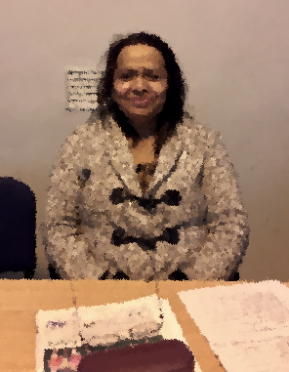

This is my friend. Her name is Anne.
She is 50 years old. She is medium height.
She is middle-aged.
She has brown eyes. She has black hair.
She is beautiful.

She is from Mauritius.
She is a cleaner.
She lives in Dublin 1.
She has been in Ireland for 10 years.
She likes travelling.

Her favourite day of the week is Sunday because she goes to church.
Her husband is a chef.
She came to Ireland to look for a good job, learn English and start a new life with her husband.


Please answer the following questions

1. What’s her name?
___________________________________________________
2. How old is she?
___________________________________________________
3. How tall is she?
___________________________________________________
4. What colour eyes does she have?
___________________________________________________
5. What colour hair does she have?
___________________________________________________
6. Where is she from?
___________________________________________________
7. What is her occupation?
___________________________________________________
8. Where does she live?
___________________________________________________
9. How long has she been in Ireland?
___________________________________________________
10. What does she like?
___________________________________________________
11. What’s her favourite day of the week and why?
______________________________________________________________________________________________________
12. What does her husband do?
___________________________________________________
13. Why did she come to Ireland?

Please write the words in the correct syllable box

▪ | ▪▪ | ▪▪▪

Anne she brown has black

beautiful Mauritius cleaner is life

likes favourite why the Sunday

church husband chef learn English

Put the words below into the correct rhyme box.

she | old | height | brown | black | goes | start | wife

wife fart tight gold three clown snack toes

down sold white art Jack knife free heart

clothes strife town mould bite nose pack sea

Break the words into syllables.
The first one is done for you.

1. | Anne | Anne
2. | brown
3. | medium
4. | beautiful
5. | cleaner
6. | Mauritius
7. | favourite
8. | Sunday
9. | black
10. | husband
11. | English
12. | Ireland
13. | travelling

Please correct the spelling

1. ifrdne _ _ _ _ _ _

2. mean _ _ _ _

3. eIdlnar _ _ _ _ _ _ _

4. cebesua _ _ _ _ _ _ _

5. ulniDb _ _ _ _ _ _

6. diumme _ _ _ _ _ _

7. ownbr _ _ _ _ _

8. ysee _ _ _ _

9. iarh _ _ _ _

10. tifulbeau _ _ _ _ _ _ _ _ _

11. nerclea _ _ _ _ _ _ _

12. daySun _ _ _ _ _ _

13. chchur _ _ _ _ _ _

- rnlea _ _ _ _ _

- artst _ _ _ _

- feli _ _ _ _

21. bandhus _ _ _ _ _ _ _ _

