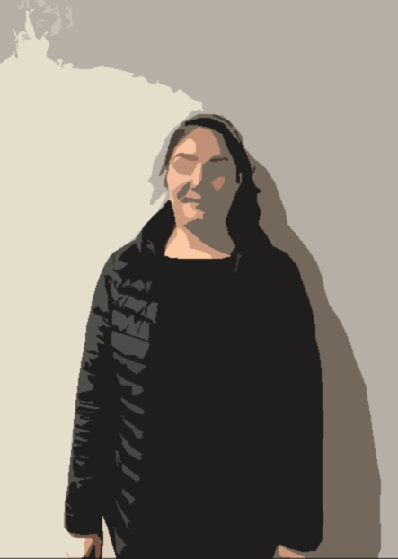

My name is Zahab.
I am your friend.
I live in Dublin 1.
I have been in Ireland since 2020.

I have one daughter.
She lives in Iran.
My dream is to bring my daughter to Ireland.

I want to learn English.
I go to English class on Monday, Tuesday, and Wednesday afternoon.





I like shopping and sport.
I sometimes walk and run in the park for one hour.
When I get back home, I eat breakfast and then I cook lunch.

I get ready at 2pm for English class. I arrive there at 2.30.

I want to get a job in the future.
My favourite job is a dress maker.



