
This is my friend. His name is Stefan.
He is 58 years old. He is 1.78 metres tall.
He is middle-aged. He is tall.
He has blue eyes. He has grey hair.
He is handsome.

He is from Moldova.
He is a tailor.
He lives in Dublin 11.
He has been in Ireland for 4 years.
He likes travelling.

His favourite day of the week is Saturday because it is his day off work.
He likes to look at the internet on his day off.
He came to Ireland to look for a good job.

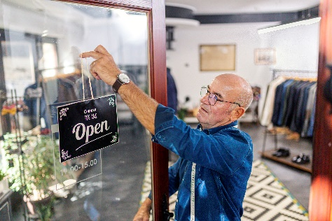
Please answer the following questions

- What’s his name?
________________________________________________
- How old is he?
________________________________________________
- How tall is he?
________________________________________________
- What colour eyes does he have?
________________________________________________
- What colour hair does he have?
________________________________________________
- Where is he from?
________________________________________________
- What is his occupation?
________________________________________________
- Where does he live?
________________________________________________
- How long has he been in Ireland?
________________________________________________
- What does he like?
________________________________________________
- What’s his favourite day of the week and why?
________________________________________________________________________________________________
- What does he like to do on his day off?
________________________________________________
- Why did he come to Ireland?
________________________________________________

Please write the words in the correct syllable box

▪ | ▪▪ | ▪▪▪

friend metres tall blue
handsome hair eyes Moldova
tailor Dublin Ireland travelling
favourite because week Saturday
internet day Ireland job

Put the words below into the correct rhyme box.

friend | name | blue | been | years | week | job | good

tears shame green knob Greek send queue mob

flood shoe beers rob queen claim spend same

weak spud bend ears mud cheek bean glue

Break the words into syllables.
The first one is done for you.

1. | Victor | Vic | tor
2. | metres
3. | middle
4. | handsome
5. | Moldova
6. | tailor
7. | Dublin
8. | Ireland
9. | travelling
10. | favourite
11. | Saturday
12. | because
13. | internet

Please correct the spelling

1. ifrdne _ _ _ _ _ _

2. mean _ _ _ _

3. eIdlnar _ _ _ _ _ _ _

4. cebesua _ _ _ _ _ _ _

5. ulniDb _ _ _ _ _ _

6. atll _ _ _ _

7. ulbe _ _ _ _

8. ysee _ _ _ _

9. iarh _ _ _ _

10. seomahdn _ _ _ _ _ _ _ _

11. ortail _ _ _ _ _ _

12. ilves _ _ _ _ _

13. arsye _ _ _ _ _

- wkee _ _ _ _

- kwor _ _ _ _

- kloo _ _ _ _

17. ternetin _ _ _ _ _ _ _ _

