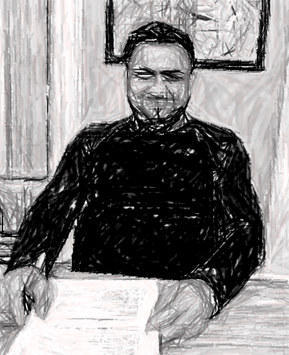

This is my friend. His name is Radu.
He is 30 years old. He is 1.68 metres tall.
He is young. He is medium height.
He has brown eyes. He has black hair.
He is handsome.

He is from Romania. He is from the Roma community.
He is a gardener.
He lives in Dublin 7.
He has been in Ireland for 4 years.
He likes school and going to church.

His favourite day of the week is Sunday because he goes to church.
He came to Ireland to have a better life.


Please answer the following questions

1. What’s his name?
_______________________________________________
2. How old is he?
_______________________________________________
3. How tall is he?
_______________________________________________
4. What colour eyes does he have?
_______________________________________________
5. What colour hair does he have?
_______________________________________________
6. Where is he from?
_______________________________________________
7. What is his occupation?
_______________________________________________
8. Where does he live?
_______________________________________________
9. How long has he been in Ireland?
_______________________________________________
10. What does he like?
________________________________________________
11. What’s his favourite day of the week and why?
________________________________________________________________________________________________
12. Why did he come to Ireland?
________________________________________________

Please write the words in the correct syllable box

▪ | ▪▪ | ▪▪▪ | ▪▪▪▪

my is handsome Roma

community Romania Dublin in

gardener medium going church

favourite Sunday better Ireland
Put the words below into the correct rhyme box.

he | height | years | young | came | been | goes | day

weigh queen ears bright knee throws

tray gears bee gene fears aim

Bray game mean write close tea

hose shame quite lung tongue stung
Break the words into syllables.
The first one is done for you.

1. | Radu | Ra | du
2. | brown
3. | medium
4. | handsome
5. | black
6. | Romania
7. | community
8. | Sunday
9. | Roma
10. | gardener
11. | Ireland
12. | travelling

Please correct the spelling

1. ifrdne _ _ _ _ _ _

2. mean _ _ _ _

3. eIdlnar _ _ _ _ _ _ _

4. cebesua _ _ _ _ _ _ _

5. ulniDb _ _ _ _ _ _

6. diumme _ _ _ _ _ _

7. ownbr _ _ _ _ _

8. ysee _ _ _ _

9. iarh _ _ _ _

10. somehand _ _ _ _ _ _ _ _

11. erdengar _ _ _ _ _ _ _ _

12. daySun _ _ _ _ _ _

13. chchur _ _ _ _ _

- oolsch _ _ _ _ _

- tterbe _ _ _ _

- feli _ _ _ _

17. itevourfa _ _ _ _ _ _ _ _

