Words and pictures. Palestinian vocabulary.
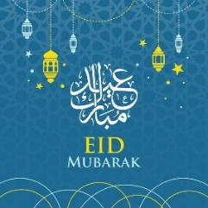 | 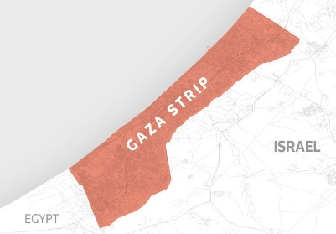 | 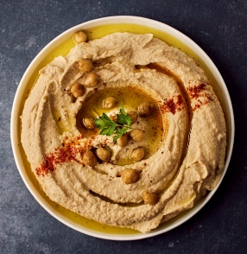
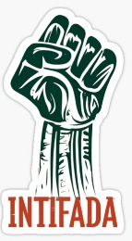 | 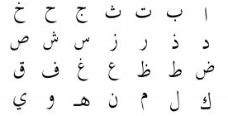 | 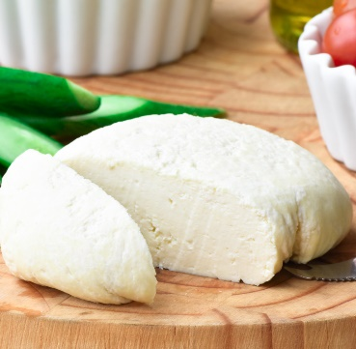
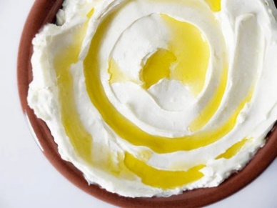 | 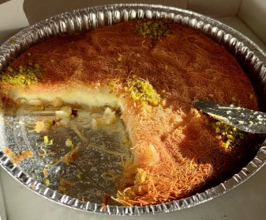 | 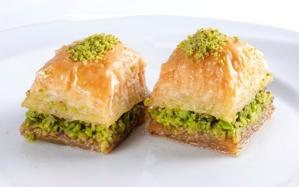
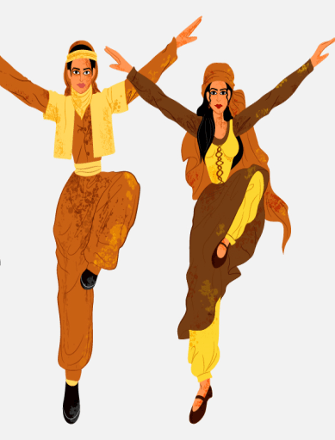 | 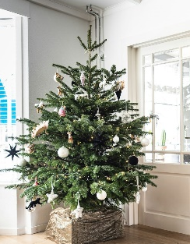 | 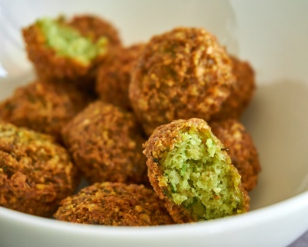
falafel dabkeh hummus baklava
Intifada labneh jubna Eid
Christmas Gaza kunafa Arabic
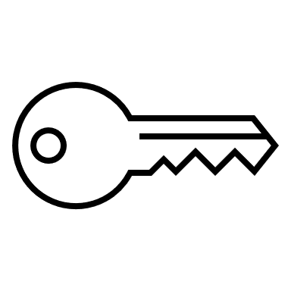 | 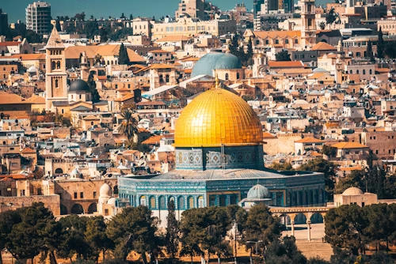 | 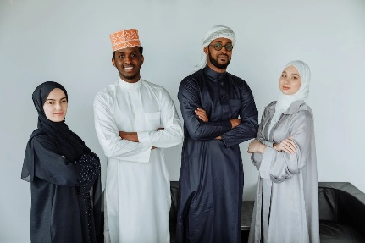
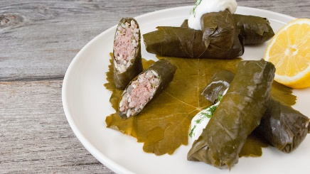 | 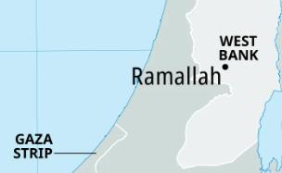 | 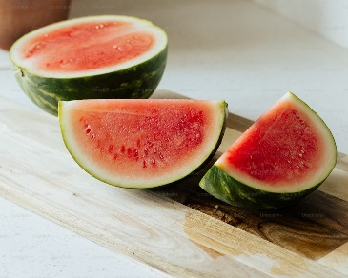
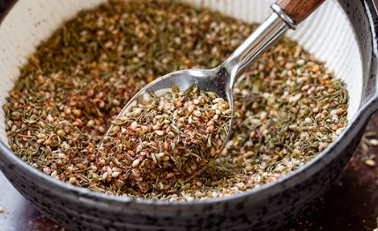 | 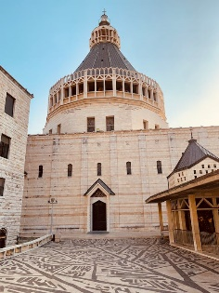 | 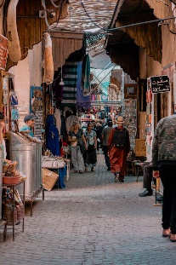
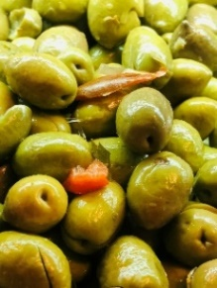 | Yallah!! | 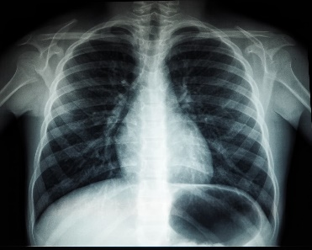
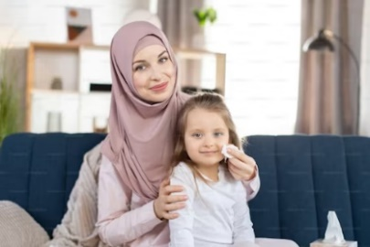 | 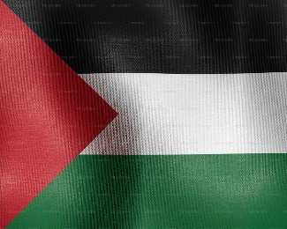
olives watermelon miftah x-ray Nazareth
za’atar Quds Ramallah sooq Yallah
umee vine thobe Palestine
Put the words in alphabetical order.
a b c d e f g h i j k l m n o p q r s t u v w x y z
1. | watermelon | a
2. | falafel | b
3. | x-ray | c
4. | Eid | d
5. | sooq | e
6. | kunafa | f
7. | miftah | g
8. | za’atar | h
9. | Christmas | i
10. | Nazareth | j
11. | dabkeh | k
12. | thobe | l
13. | baklava | m
14. | olives | n
15. | Gaza | o
16. | Quds | p
17. | labneh | q
18. | umee | r
19. | hummus | s
20. | jubna | t
21. | Palestine | u
22. | Ramallah | v
23. | Yallah | w
24. | Arabic | x
25. | vine | y
26. | Intifada | z

Syllable work

- Arabic

- baklava

- Christmas

- dabkeh

- Eid

- falafel

- Gaza

- hummus

- Intifada

- jubna

- kunafa

- labneh

- miftah

- Nazareth

- olives

- Palestine

- Quds

- Ramallah

- sooq٭

- thobe

- umee٭٭

- vine

- watermelon

- x-ray

- Yallah

- za’atar
٭sooq is usually spelt souk ٭ ٭umee is usually spelt umi
Palestine
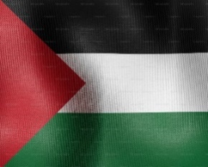
Missing words: Food and Drinks
- _ _ _ _ _ _ _ 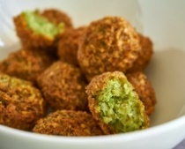 and _ _ _ _ _ _ 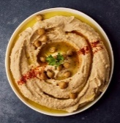 are popular foods in Palestine.

- _ _ _ _ _ _ 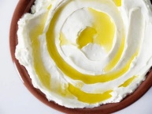 is a creamy yogurt, and _ _ _ _ _ 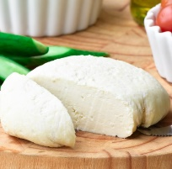 is a type of cheese.
- _ _ _ _ _ _ 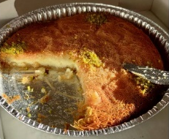 and _ _ _ _ _ _ _ 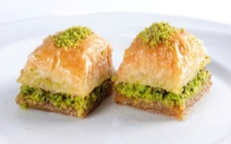 are sweet desserts.

- _ _ _ _ _ _ 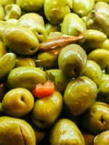 and _ _ _ _ _ _ _ _ _ _ 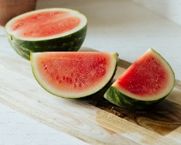 are common fruits.

- _ _ _ _ _ _ 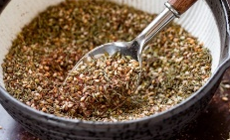 is a spice mix used on bread and other dishes.
Clothing and Dance
- People wear a traditional dress called a _ _ _ _ _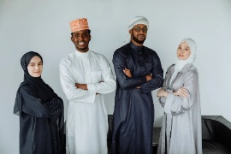
- Palestinians dance the _ _ _ _ _ _ at celebrations.

Holidays
- Palestinians celebrate _ _ _ 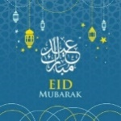 and _ _ _ _ _ _ _ _ _ 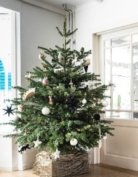 with family and friends.

Cities and Symbols
- _ _ _ _ _ _ _ _ 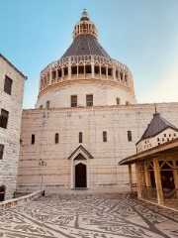 , _ _ _ _ 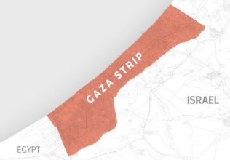 and _ _ _ _ _ _ _ _ are cities in Palestine.

- The _ _ _ _ _ _ (key) is a symbol of return for Palestinians. Many Palestinians lost their homes in the Nakba.
- The word _ _ _ _ _ _ _ _ 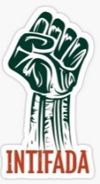 means rebellion or uprising, an important part of Palestinian history.
Other Words
- _ _ _ _ 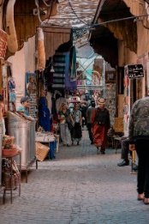 is a market where people buy and sell things.

- _ _ _ _ _ _ Yallah!! means "let’s go!".

- _ _ _ 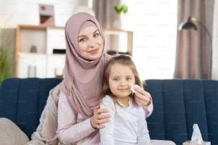 means "my mother".

- People speak _ _ _ _ _ _ in Palestine.
- _ _ _ _ is a very historical city.
٭ al-Quds is the Arabic name for Jerusalem

Matching
1. | falafel |  | sweet dessert
2. | dabkeh |  | yoghurt
3. | baklava |  | key
4. | Intifada |  | mother
5. | labneh |  | rebellion
6. | jubna |  | language
7. | Eid |  | cheese
8. | Gaza |  | popular food
9. | miftah |  | spice
10. | Arabic |  | market
11. | umi |  | traditional dance
12. | Za’atar |  | historical city
13. | souk |  | fruit
14. | watermelon |  | celebration
Finish the sentences

- In Palestine, people speak ___________________________.

- The traditional dance is called _______________________.

- ________________ and __________________ are popular foods in Palestine.

- Palestinians celebrate ________ and __________________.

- The market is called a _____________________________.

True or false

- Kunafa is a type of dance. __________________________.

- Eid is a holiday celebrated in Palestine. _________________.

- The souk is a type of food. __________________________.

- Umi means “my mother.” ____________________________.

- Gaza is a city in Palestine. ___________________________.

Writing: write a short sentence with each word

- Eid:
_______________________________________________
_______________________________________________

- Christmas:
______________________________________________________________________________________________

- Arabic:
______________________________________________________________________________________________

- Baklava:
______________________________________________________________________________________________

- Falafel:
______________________________________________________________________________________________

- Watermelon:
______________________________________________________________________________________________

- Olives:
______________________________________________________________________________________________

Answers for Page 1. Words and pictures.
Eid | Gaza | hummus
Intifada | Arabic | jubna
labneh | kunafa | baklava
dabkeh | Christmas | falafel

Answers for Page 2. Words and pictures.
miftah | Gaza | thobe
vine | Ramallah | watermelon
Za’atar | Nazareth | sooq
 | Yallah!!
olives | Yallah | x-ray
umee | Palestine

